Two Turkey’s Sheepdog Trial Act I

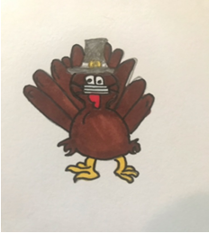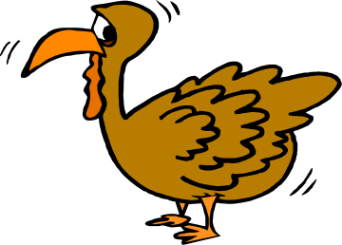

Magnolia Farm

Roseburg, Oregon

Friday November 27, 2026

^{USBCHA, OSDS}
Judge: Elizabeth Baker

Start Time: Handlers meeting at 7:30 a.m.

Open Pro Novice: International Style (smaller field)
Awards: Points only
Sheep: All breeds represented Sheep replacement fee $350
Location: 5843 Buckhorn Road, Roseburg, OR. Driving directions on back of entry form
Entry Fee - Open – $55 per class Pro Novice - $55 per class

ENTRY DEADLINE: Entries open November 2 and close November 9, 2026. No refunds after November 15, 2026
Entries will be limited to 45-50 dogs total. Please send separate checks for Open ProNovice
Mail Entries & Checks Payable to:
Elissa Thau, Two Turkeys SDT
5843 Buckhorn Rd.
Roseburg, OR 97470-9305

Handler Name___________________________________________________________________________

Address_____________________________________________________Phone No.___________________

e-mail address________________________________________________________________________

Dog____________________________________Class___________________ Entry Fee____________

Dog____________________________________Class___________________ Entry Fee____________

Dog____________________________________Class___________________ Entry Fee____________

Dog____________________________________Class___________________ Entry Fee____________

Total _____________
________________________________________________________ ____________________________
Signature Date

Two Turkey’s Winter Sheepdog Trial Act I

Magnolia Farm Trial

5843 Buckhorn Rd. Roseburg Or.
(541) 580-4378

November 27, 2026

WAIVER AND RELEASE
I, the undersigned, for and in consideration of my permission to participate in the Two Turkeys Winter Sheepdog Trial Act III or any other Elissa Thau, Carlos Compeau and or Magnolia Farm trials, and other activities associated with the foregoing, do release and discharge Elissa Thau and or Magnolia Farm, their heirs, successors, personal representatives, workers and assigns and any and all persons, corporations or firms on their behalf from all claims, demands, damages, debts, executions, actions or causes of action arising from or growing out of any and all personal injuries and property damage that I or my heirs, successors, assigns or representatives may hereafter incur as a result of my participation in the event, including injury or damages arising from future negligence or fault of Elissa Thau, Carlos Compeau and or Magnolia Farm agents or representatives, or the condition or maintenance of any facility utilized by the undersigned.

In executing this release, I rely solely upon my own judgement without influence by anyone else, and knowingly and voluntarily enter into the same for the purposes set forth above. I fully understand that by entering into this release I am agreeing to forego all causes of action of any kind against Elissa Thau, Carlos Compeau and or Magnolia Farm whether now known or arising thereafter.

I acknowledge that this event will include potential interaction with animals, whether mine, or other participants’ or Elissa Thau, Carlos Compeau and or Magnolia Farm. I acknowledge that animals can behave in unpredictable manners, and that I fully assume all risk associated with my interaction with these animals.

I HAVE FULLY READ AND UNDERSTAND THE PROVISIONS OF THE ABOVE AND FOREGOING AGREEMENT AND WISH TO BE BOUND BY TS TERMS.

_______________________________________________________________ __________________________
Signature Date

Driving Directions: From the North and South:
I-5 Roseburg exit 124 (“To Hwy 138 Diamond Lake / Glide”). Follow signs through Roseburg to Diamond Lake / Glide (Hwy 138 East). Drive approximately 5 miles on Diamond Lake Blvd. Turn right at the Dixonville sign. This takes you to Buckhorn Rd. Proceed east (left) on Buckhorn Rd. You’ll see the Dixonville Store on the left. Go 3.8 miles past the Dixonville Store. Magnolia Farm is on the right. Continue to the next road on the right Strawberry Mtn Road. Parking is through the first gate on the right on Strawberry Mtn Rd.

Parking will be in Strawberry Mountain field NOT at the house. Participants will be notified a week prior to trial of any parking changes.

